**SSN College of Engineering, Kalavakkam**

**Department of Computer Science and Engineering**

**III Semester - CSE**

# UCS 1312 Data Structures Lab Laboratory

|  |  |
| --- | --- |
| **Academic Year: 2021-2022** | **Batch: 2020-2024** |
| **Date of Assignment: 13.11.2021** | |

**Exercise 8: Dictionary Application using AVL Tree**

**[CO2,K3]**

The structure AVL has integer data and pointers to left and right children. Implement the following methods.

* void insert(struct AVL *t, int x) – Insert an integer data into BST
* void inorder(struct AVL *t) – Display the tree using inorder traversal
* void display(struct AVL *t) – Display the tree in hierarchical manner

Create AVLADTImpl.h with the implementations of the above-mentioned operations

Create AVLADTAppl.c that utilizes BSTADT and BSTADTImpl to perform the operations.

1. Demonstrate the AVLADT with the following test case

Insert(t,23)

Insert(t,12)

Insert(t,13)

Insert(t,4)

Insert(t,45)

Insert(t,54)

Inorder(t) 🡪 4,12,13,23,45,54

Display(t) will display the tree as follows

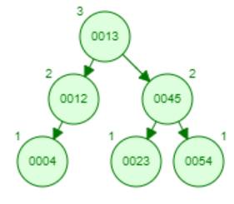

1. Write an application to do the following

Develop a dictionary application using AVL Tree. Convert the AVLADT to include word and the meaning. Implement the following methods.

* void insert(struct dictionaryADT *D, struct wordMeaning x) – Insertion of a new word and meaning into dictionary
* void disp(struct dictionaryADT *D) – Display all the words and their meanings in ascending order
* void search(struct dictionaryADT *D, char word[]) – Will search for a word and provides its meaning

Test the application with the following testcase

Insert(“bisk”,”soup”)

Insert(“cite”,”refer”)

Insert(“boom”,”sound”)

Insert(“able”,”opportunity”)

Insert(“aged”,”old”)

Insert(“crew”,”group of people”)

Display AVL tree – ascending order

Able - opportunity

Aged - old

Boom - sound

Crew - group of people

Bisk - soup

Cite - refer

Search for a word to find the meaning

Input: Cite

Output: Refer